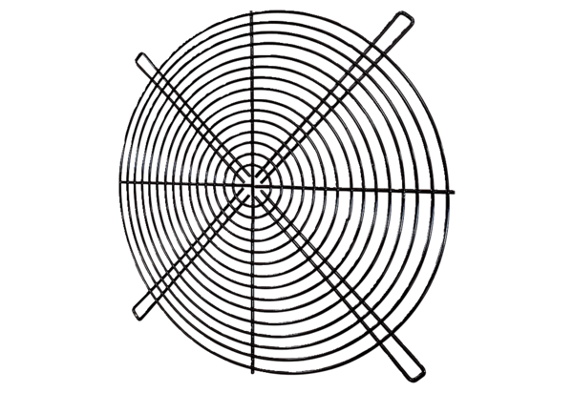Protective grille SGRI 50Packing unit: 1 pieceRange: C
Article number: 0073.0044Manufacturer: MAICO

