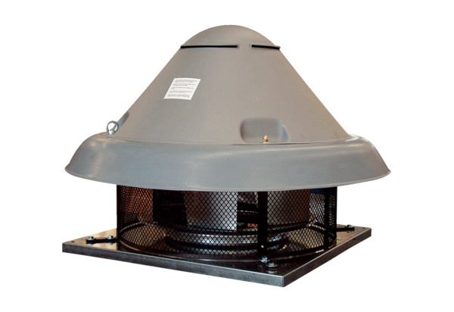Centrifugal roof fan DRD H 56/6Packing unit: 1 pieceRange: C
Article number: 0073.0057Manufacturer: MAICO

