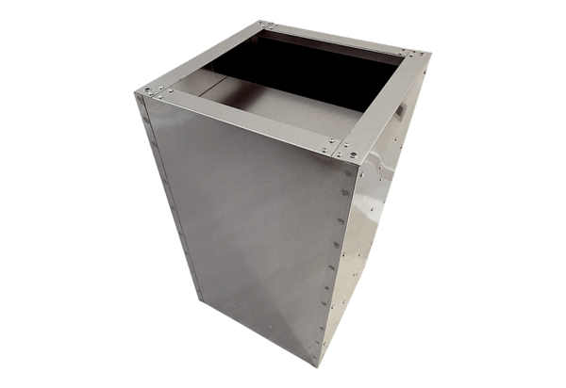Socket sound absorber SDVI 80-90<data>
<p class="FT">Packing unit:</p>
</data>
1 piece<data>
<p class="FT">Range:</p>
</data>
C
<data>
<p class="FT">Article number:</p>
</data>
0073.0065<data>
<p class="FT">Manufacturer:</p>
</data>
MAICO

