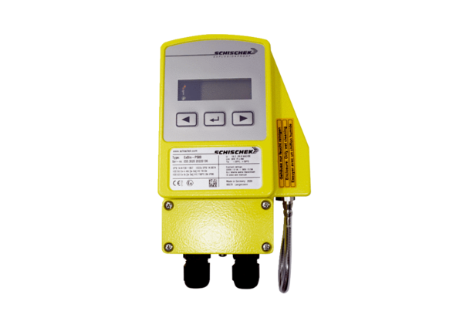Differential pressure switch DDEx 500Packing unit: 1 pieceRange: C
Article number: 0157.0302Manufacturer: MAICO

