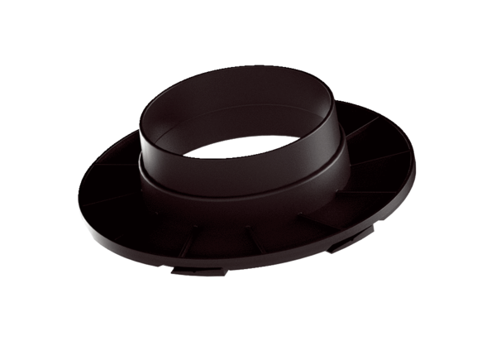Connection coupling MA-AÜ125Packing unit: 1 pieceRange: K
Article number: 0059.2140Manufacturer: MAICO

