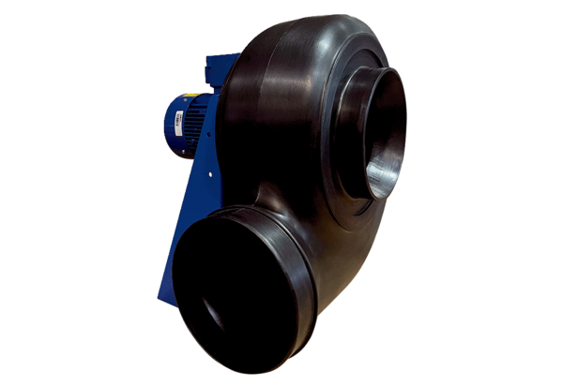Centrifugal blower GRK R 25/4 D ExPacking unit: 1 pieceRange: C
Article number: 0073.0443Manufacturer: MAICO

