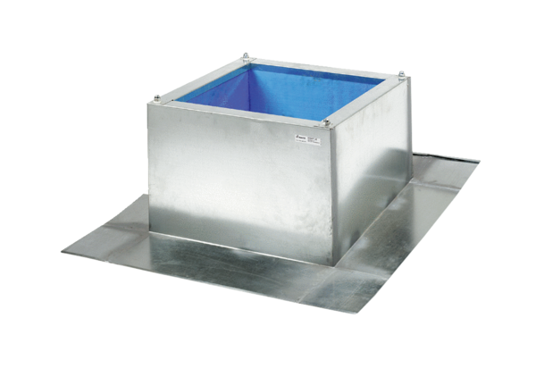Roof socket for corrugated and trapezoidal roofs SOWT 31Packing unit: 1 pieceRange: C
Article number: 0093.0986Manufacturer: MAICO

