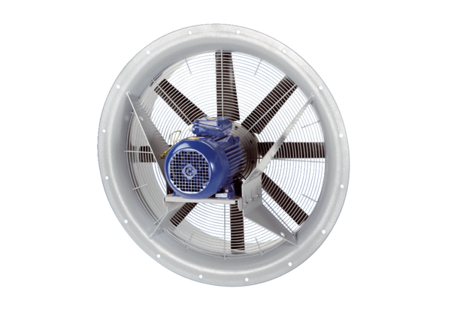Axial fan DAS 125/8Packing unit: 1 pieceRange: C
Article number: 0083.0865Manufacturer: MAICO

