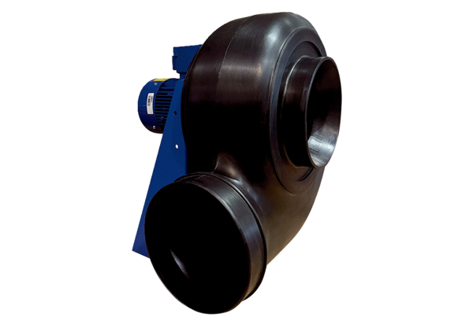Centrifugal blower GRK R 40/6 D ExPacking unit: 1 pieceRange: C
Article number: 0073.0453Manufacturer: MAICO

