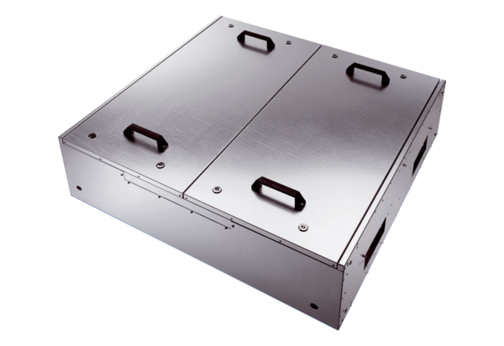Sound-insulated ventilation box KFD 9040Packing unit: 1 pieceRange: K
Article number: 0080.0965Manufacturer: MAICO

