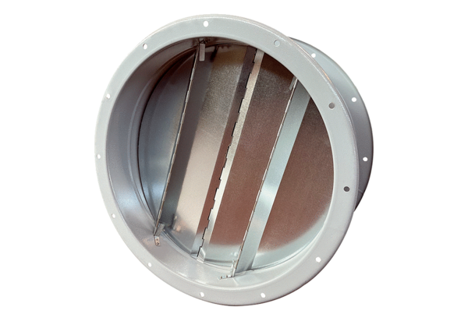Duct shutter VKRI R 63Packing unit: 1 pieceRange: C
Article number: 0073.0088Manufacturer: MAICO

