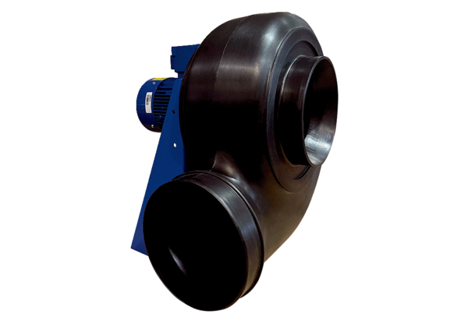Centrifugal blower GRK R 31/2 D ExPacking unit: 1 pieceRange: C
Article number: 0073.0446Manufacturer: MAICO

