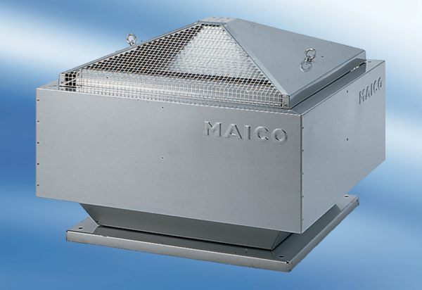Centrifugal roof fan DRD 50/8Packing unit: 1 pieceRange: C
Article number: 0087.0116Manufacturer: MAICO

