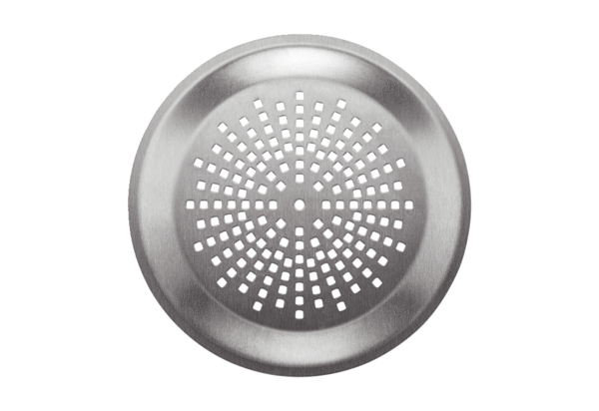Wall/Ceiling grille FFS-WGEPacking unit: 1 pieceRange: K
Article number: 0055.0903Manufacturer: MAICO

