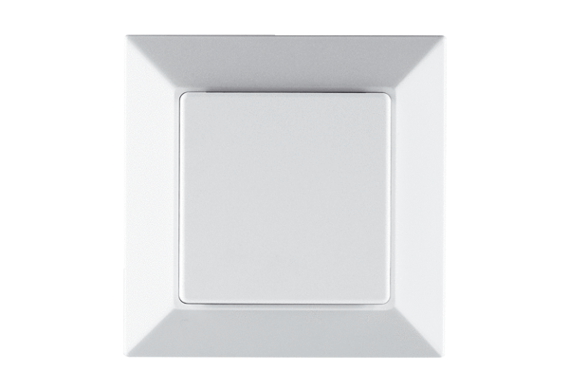CO2 sensor PP 45 CO2Packing unit: 1 pieceRange: K
Article number: 0157.0366Manufacturer: MAICO

