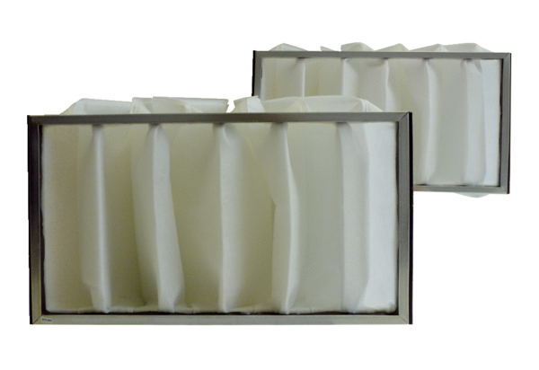Air filter, replacement KF 31Packing unit: 2 piecesRange: D
Article number: 0093.0684Manufacturer: MAICO

