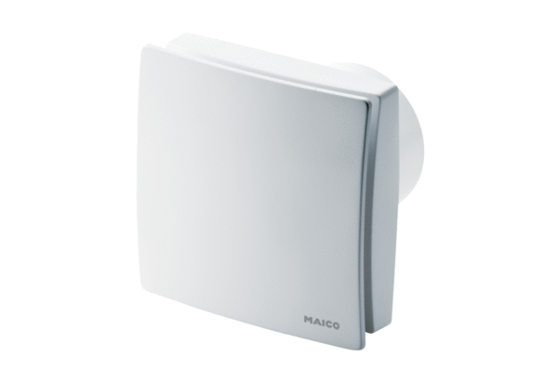Small room fan ECA 150 ipro KRCPacking unit: 1 pieceRange: A
Article number: 0084.0093Manufacturer: MAICO

