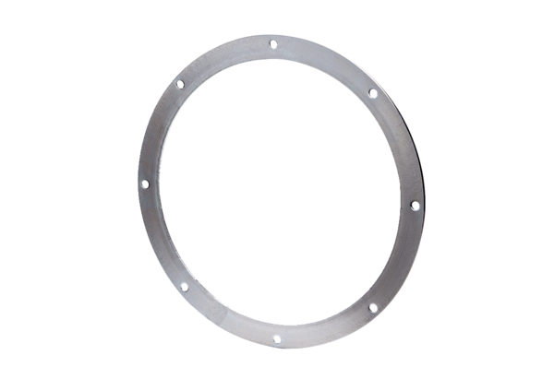Counter flange GF 60Packing unit: 1 pieceRange: C
Article number: 0056.0009Manufacturer: MAICO

