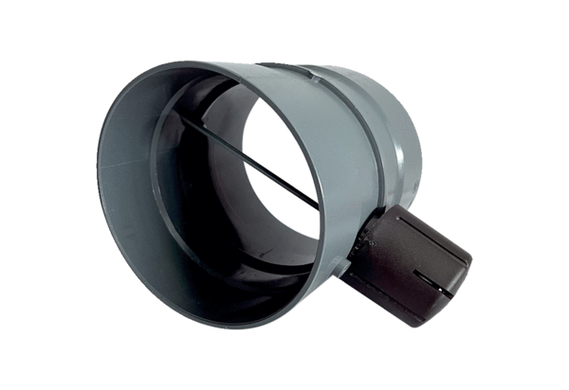Manual throttle valve MDKI 31Packing unit: 1 pieceRange: C
Article number: 0073.0483Manufacturer: MAICO

