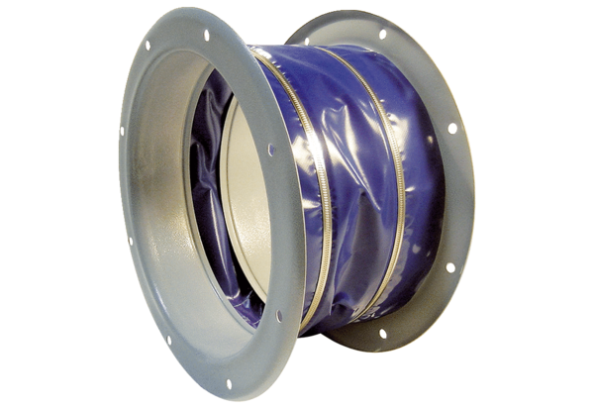Flexible coupling ELI 112Packing unit: 1 pieceRange: C
Article number: 0073.0223Manufacturer: MAICO

