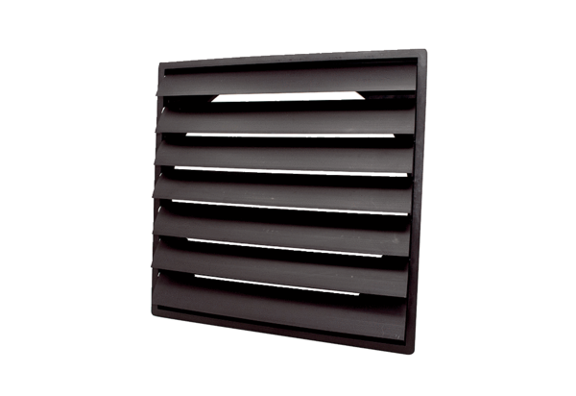Shutter AS 35 ExPacking unit: 1 pieceRange: C
Article number: 0151.0405Manufacturer: MAICO

