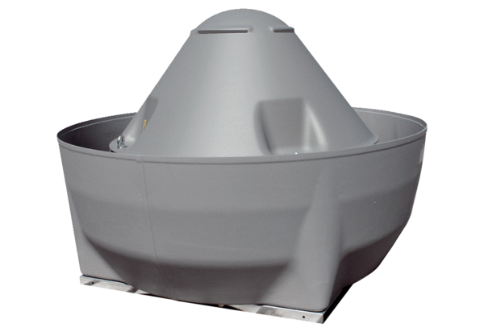Centrifugal roof fan ERD V 40/4 ExPacking unit: 1 pieceRange: C
Article number: 0073.0547Manufacturer: MAICO

