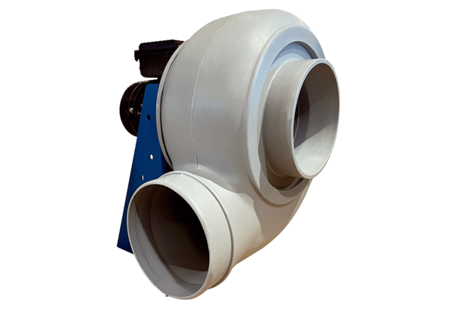Centrifugal blower GRK R 25/2 DPacking unit: 1 pieceRange: C
Article number: 0073.0514Manufacturer: MAICO

