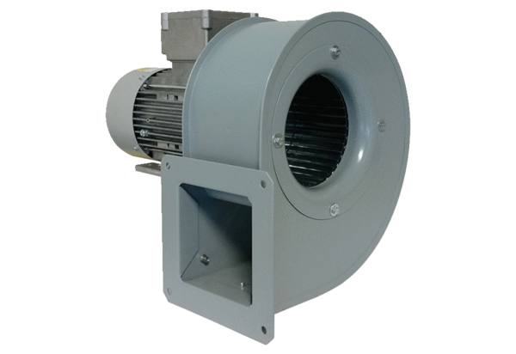Centrifugal blower GRM 16/2 D ExPacking unit: 1 pieceRange: C
Article number: 0073.0389Manufacturer: MAICO

