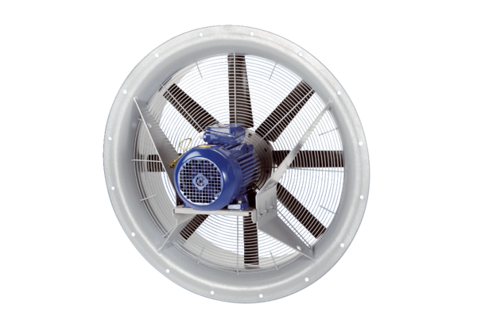Axial fan DAS 100/8Packing unit: 1 pieceRange: C
Article number: 0083.0860Manufacturer: MAICO

