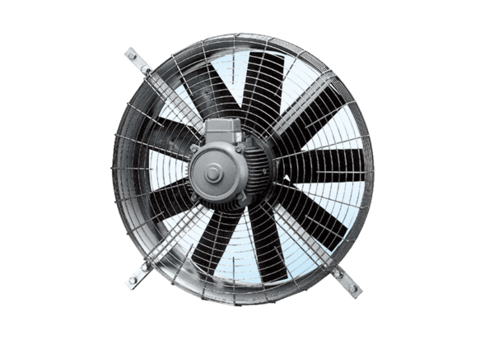Axial wall fan DZQ 100/6Packing unit: 1 pieceRange: C
Article number: 0083.0648Manufacturer: MAICO

