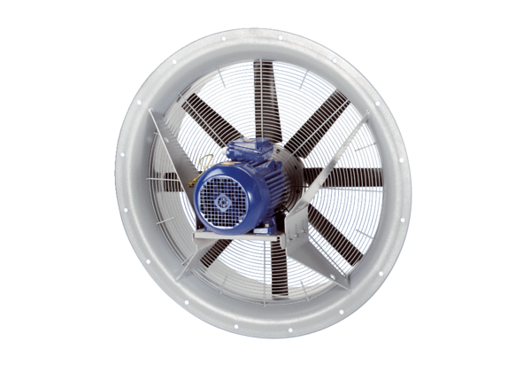Axial fan DAS 80/8Packing unit: 1 pieceRange: C
Article number: 0083.0854Manufacturer: MAICO

