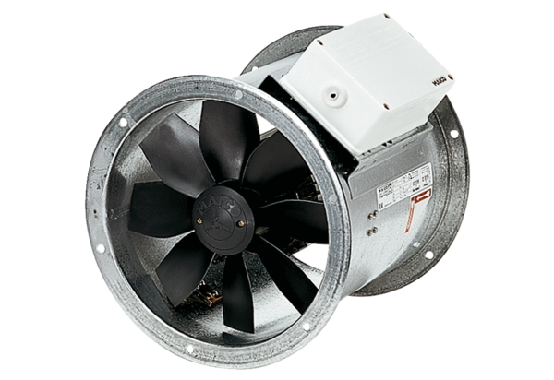Axial duct fan DZR 25/84 BPacking unit: 1 pieceRange: C
Article number: 0086.0040Manufacturer: MAICO

