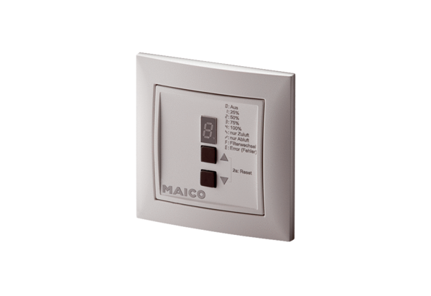Room air control RLS 4-1 UPPacking unit: 1 pieceRange: K
Article number: 0157.0848Manufacturer: MAICO

