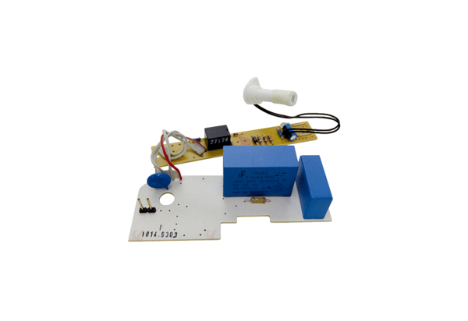Circuit board PL AP ER 60 FRange: B
Article number: E101.1014.9303Manufacturer: MAICO

