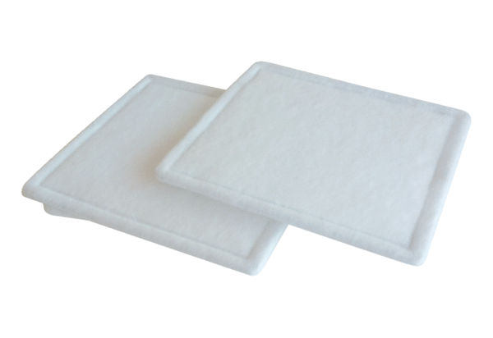Air filter, replacement RF 12-4Packing unit: 2 piecesRange: C
Article number: 0093.0069Manufacturer: MAICO

