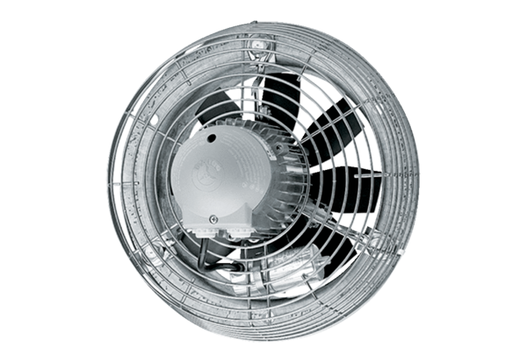Axial wall fan DZS 60/86 BPacking unit: 1 pieceRange: C
Article number: 0094.0070Manufacturer: MAICO

