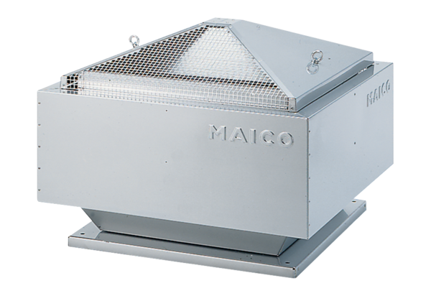Centrifugal roof fan DRD 45/6 BPacking unit: 1 pieceRange: C
Article number: 0087.0111Manufacturer: MAICO

