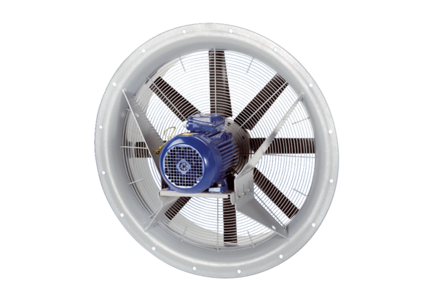Axial fan DAS 71/4Packing unit: 1 pieceRange: C
Article number: 0083.0853Manufacturer: MAICO

