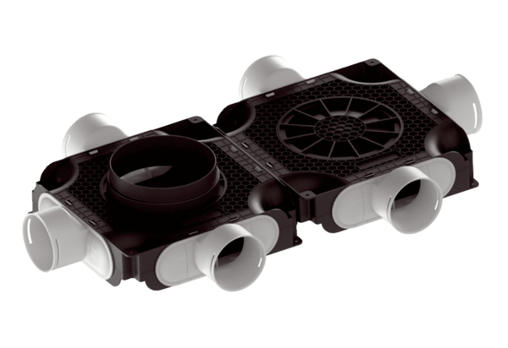Flat and compact double air distributor, made of plastic, 6-way MA-FDV6-90Packing unit: 1 pieceRange: K
Article number: 0059.2129Manufacturer: MAICO

