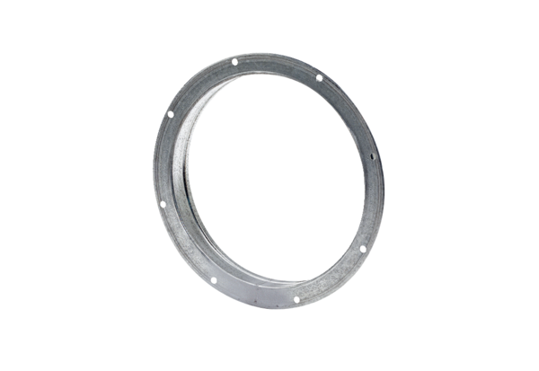Counter socket GS 56Packing unit: 1 pieceRange: C
Article number: 0055.0176Manufacturer: MAICO

