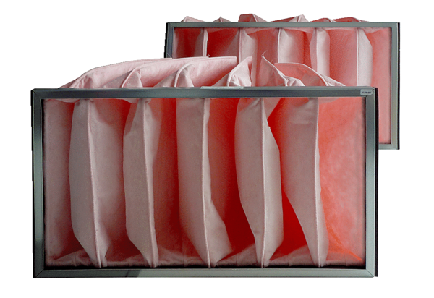Air filter, replacement KF 35-7Packing unit: 2 piecesRange: D
Article number: 0093.0867Manufacturer: MAICO

