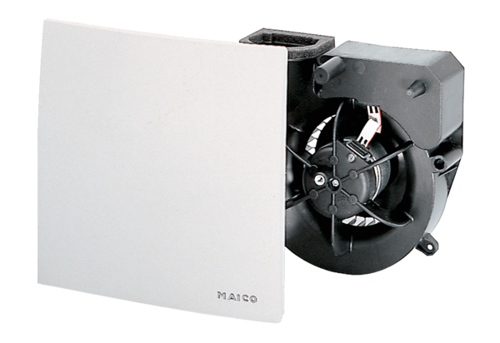Fan insert ER 100 VZCPacking unit: 1 pieceRange: B
Article number: 0084.0136Manufacturer: MAICO

