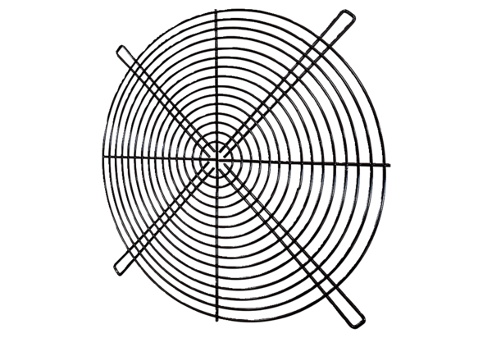Protective grille SGRI 71Packing unit: 1 pieceRange: C
Article number: 0073.0207Manufacturer: MAICO

