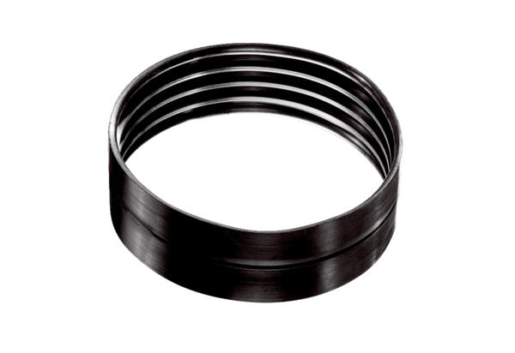Ventilation duct connector MT-V160Packing unit: 1 pieceRange: K
Article number: 0059.0988Manufacturer: MAICO

