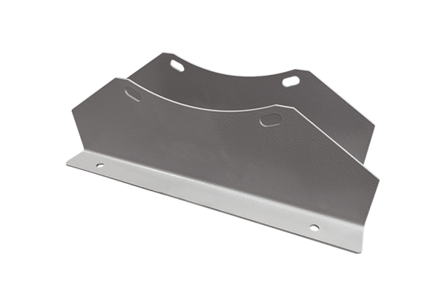Mounting foot FUI 71Packing unit: 1 pieceRange: C
Article number: 0073.0226Manufacturer: MAICO

