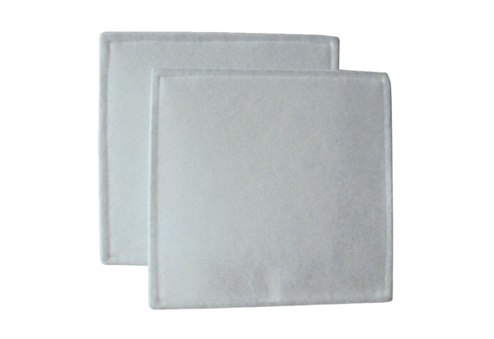Air filter, replacement RF 40Packing unit: 2 piecesRange: C
Article number: 0093.0692Manufacturer: MAICO

