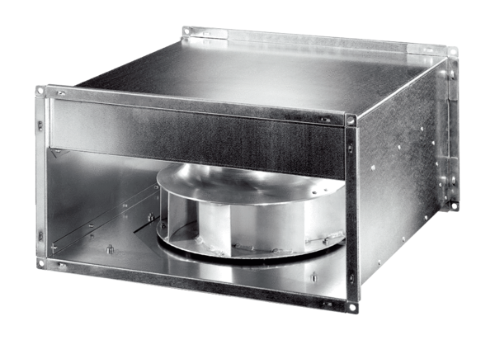Channel fan DPK 56 ECPacking unit: 1 pieceRange: E
Article number: 0086.0810Manufacturer: MAICO

