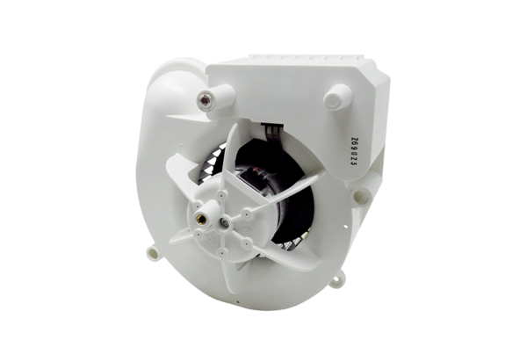Fan insert VE ER-AP 60 FRange: B
Article number: E084.0152.0000Manufacturer: MAICO

