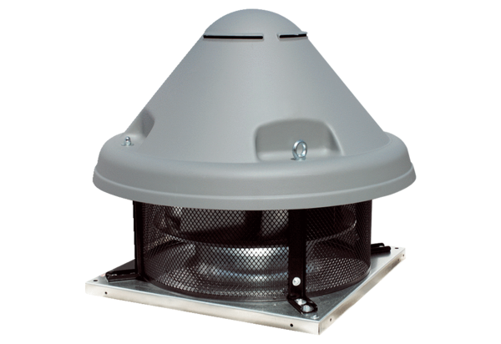Centrifugal roof fan DRD H 75/6 ExPacking unit: 1 pieceRange: C
Article number: 0073.0542Manufacturer: MAICO

