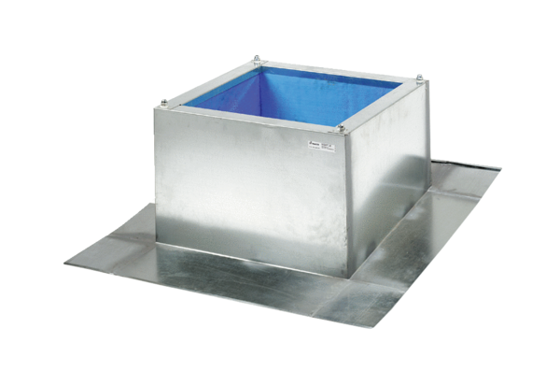Roof socket for corrugated and trapezoidal roofs SOWT 18Packing unit: 1 pieceRange: C
Article number: 0093.1031Manufacturer: MAICO

