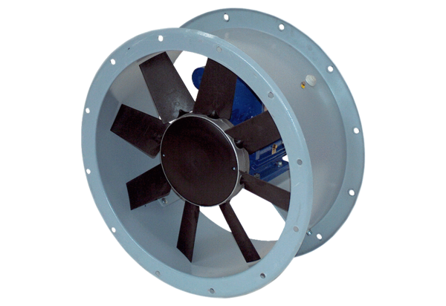Axial duct fan DAR 63/4-2 ExPacking unit: 1 pieceRange: C
Article number: 0073.0347Manufacturer: MAICO

