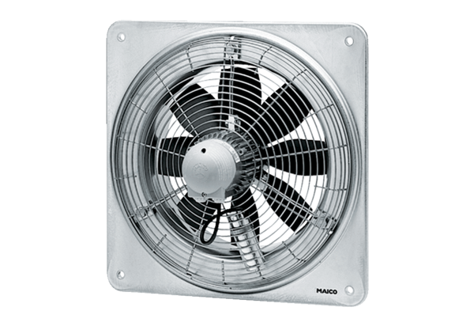Axial wall fan EZQ 50/6 BPacking unit: 1 pieceRange: C
Article number: 0083.0113Manufacturer: MAICO

