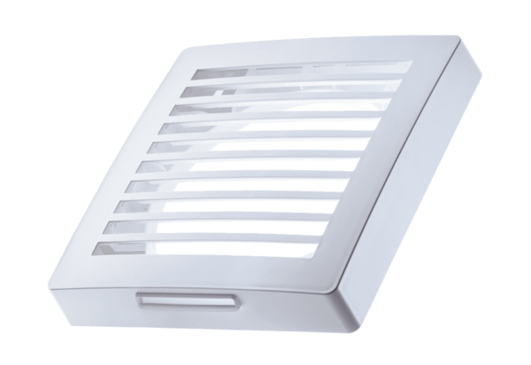External cover PP 45 AKPacking unit: 1 pieceRange: K
Article number: 0093.0176Manufacturer: MAICO

