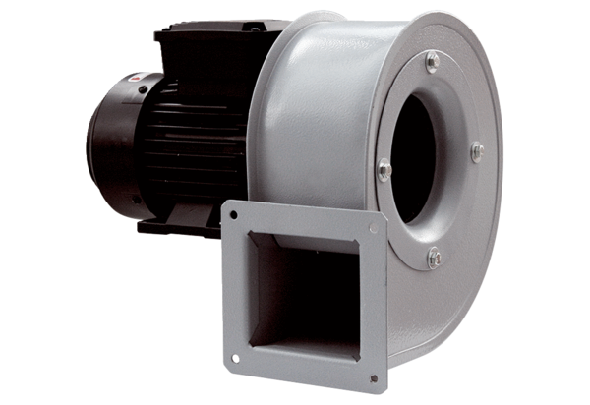Centrifugal blower GRM HT 14/2Packing unit: 1 pieceRange: C
Article number: 0073.0281Manufacturer: MAICO

